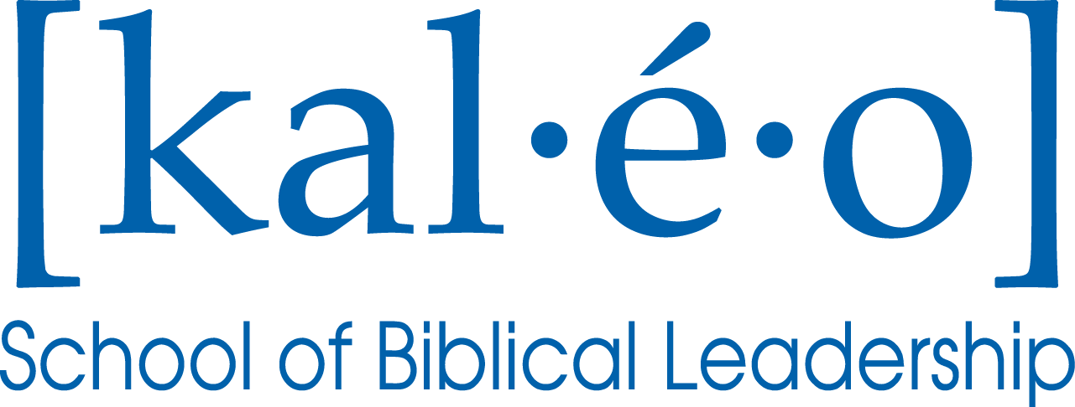

**Level Two of Christ Fellowship’s**

**Leadership Development Pathway**

**Summary & Information**

**Provided and Copyrighted by:**

Christ Fellowship Church, Palm Beach Gardens, FL

**Revised**: September 2012

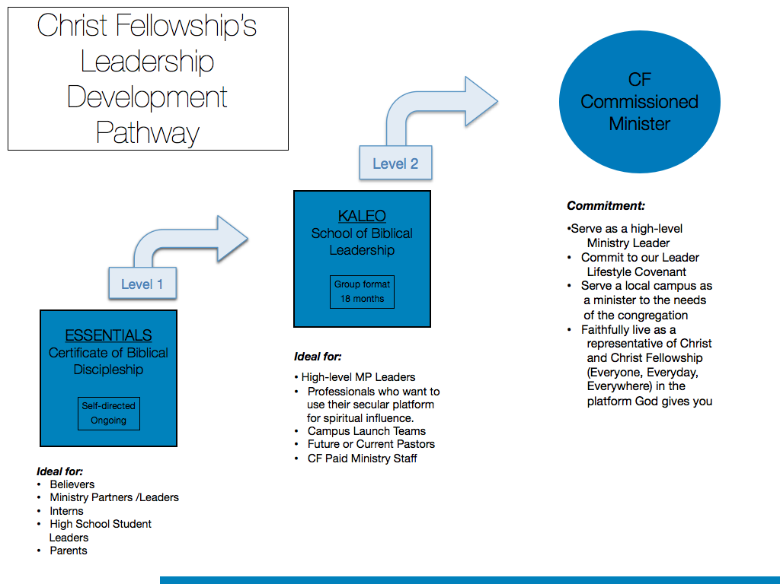

**Kaleo Mission**

Kaleo exists to fully equip God’s people in Biblical Leadership in order to effectively serve as agents of radical transformation in all sectors of the Church and society.

**Kaleo Name**

The word “kaleo” come from the Greek and means “to be called out, appointed and designated for a specific purpose.”

**Kaleo Strategy**

Kaleo is a 14-month intensive training program designed to challenge and develop participants in three areas simultaneously:

* Personal spiritual growth (Character)
* Their understanding and use of the Bible (Theology)
* Their ability to lead and influence others (Leadership Skills)

This transformational experience involves faculty taught core curriculum, mentor-led interactive communities (called cadres), and optional specialty elective training. Our approach to growing Kaleo is to start small and locally while simultaneously thinking big and designing it for scalability.

**Who is Kaleo’s ideal student?**

Kaleo is designed for believers who are individually pursuing their relationship with Christ, leading others spiritually, actively serving in church ministry, and sense a calling to grow in their spiritual influence within the platform God has given them. The program is designed for leaders who work outside the church with classes and workshops held on evenings and weekends.

**What makes Kaleo unique in the classroom?**

Using principles of **Transformational Education Theory** (learner-centered paradigm) which suggests that adult learners need three primary experiences to shift their way of thinking and leading:

1. Quality Content (provided by our in-house faculty)
2. Self-reflection and applying their own life experiences to the content (through reflective homework assignments)
3. Engaging and challenging conversations (done in class through weekly Cadre Discussions)

And, incorporating **Multiple Intelligence Theory** as much as possible. This theory suggests that people learn in a variety of ways, including eight types of “intelligences”. Kaleo faculty work to present their information through as many learning styles as possible.

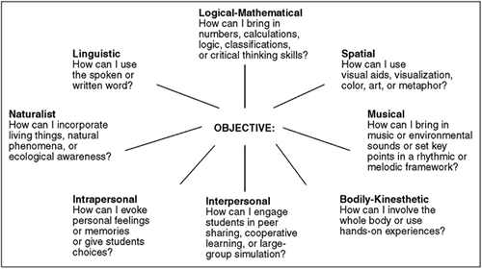

**Attributes of a Kaleo Graduate**

***Character***

**The Kaleo graduate will ….**

* Live from a foundation of emotional wholeness, soul health, and personal integrity.
* Lead from a place of relational health and strength.
* Practice spiritual disciplines and accountability.
* Implement, apply, and exercise the fundamentals of self-leadership.
* Understand and practice faithful stewardship of all that God has entrusted to him/her.
* Cultivate and exemplify a heart of humility, integrity, and security in Christ.

***Theology***

**The Kaleo graduate will ….**

* Understand the authority of God’s Word and the foundations of Christian doctrine.
* Make disciples of people in all stages of spiritual maturity.
* Study, interpret, and communicate biblical truth effectively in different settings.
* Express the heart of CF’s leadership in a variety of ministry situations.
* Understand the nature, mission, and future of the Church.
* Engage in spiritual battle with wisdom and biblical truth.

***Leadership***

**The Kaleo graduate will ….**

* Understand the Biblical perspective and principles of effective leadership.
* Spiritually care for and disciple others through Scriptures, ministry skills, and the leading of the Holy Spirit.
* Communicate effectively one-on-one and as a facilitator, teacher, and preacher.
* Develop and lead individuals, groups, and teams.
* Lead effectively through change.
* Embrace and embody servant leadership with humility and respect for authority.

**Kaleo: Course & Workshop Catalog**

**Soul Health & Self Leadership**:

***Sequence*:** Course #01

***Description:*** The course will walk participants through the foundational principles of self-leadership, including emotional wholeness, soul health, personal integrity, personal spiritual disciplines, spiritual accountability, and time management.

***Required Reading:***

Emotionally Healthy Spirituality, by Peter Scazzero

7 Habits of Highly Effective People, by Stephen Covey

Choosing to Cheat, by Andy Stanley

***Required Audio / Video recordings:***

“Private vs. Public” Audio CD, by A. Bernard

”The Leader’s Inner World” Audio , by Wayne Cordeiro

**Servant Leadership**:

***Sequence*:** Course #02

***Description:*** Jesus redefined leadership and cast a mold contrary to what many in the world envision a leader to be. Throughout this course, you will examine biblical and modern-day examples that will shed light on the essentials servant leadership. Your journey will take you from the heart-level raw ingredients to actual practices that will empower you to lead in ways that advance God’s kingdom purposes in the world.

***Required Reading:***

The Mentor, by Kadi Cole

Tale of Three Kings, by Gene Edwards

**Spiritual Power**:

***Sequence*:** Course #03

***Description***: Spiritual power is available to believers for freedom and healing. The New Testament church was known for it faith and spiritual authority. Todaywar is being waged against Christians by spiritual forces of evil. (Ephesians 6:10-12) Within the Church, there are those who are oppressed. This course is designed to provide tools for leaders to use in assisting the hurting and tormented to find relief through Christ. Christ Fellowship policies for helping these individuals find inner healing is explored.

***Required Reading:***

Two Hours to Freedom, by Charles Kraft

Steps to Freedom in Christ, by Neil T. Anderson

**Stages & Styles of Leadership**:

***Sequence*:** Course #04

***Description:*** An important part of leadership is knowing your own strengths, styles and stages of leadership and where you are in your own journey so that you can lead and serve others well. This course includes practical assessments and instruction on how to understand your own leadership style and stage, and identify the leadership styles and stages of others in order to have the most effective working relationships. Goals of this course will culminate in developing a leadership dashboard along with a leadership growth plan.

***Required Reading:***

Developing the Leader Within You, by John Maxwell

StrengthsFinders 2.0, by Tom Rath

***Required Assessments:***

Myers-Briggs

DISC

**Interpersonal Ministry Skills**:

***Sequence*:** Course #05

***Description***: Interpersonal Ministry Skills is a course designed to equip students with the best methods in responding to and resolving issues in a variety of situations within ministry. There are foundational tools that are appropriate and useful in interpersonal ministry conversations, and this course will equip the students with those foundational elements. Other practical topics include guiding principles for challenging ministry situations and conflict resolution. This course will also bring to light topics that provide a greater awareness of multi-cultural and multi-generational diversities, as well as appropriate uses for media in ministry.

***Required Reading:***

Peacemaker, by Ken Sande

*“Summary of Intentional Interviewing & Counseling”*, by Mona Egea

***Required Assessments:***

EQi – Workplace Assessment

**Biblical Interpretation, Using the Gospels**:

***Sequence*:** Course #06

***Description***: The Biblical Interpretation course will equip students with practical hermeneutical skills and tools of biblical interpretation, utilizing the Gospels to practice those skills and thereby gain a deeper knowledge of the Gospels. The use of concordances, commentaries, and Bible translations, along with passage comparisons and diagrammatical analysis will be some of the practical skills taught during this course.

***Required Reading:***

The Gospel of Matthew

The Gospel of Mark

The Gospel of Luke

The Gospel of John

“*A Survey of the Gospels: Kaleo Course Guide*” by Daniel Light

“*Principles of Biblical Interpretation*” by Daniel Light

***Provided iPad Apps:***

Matthew Henry Commentary App

Strong’s Concordance App

**Team Building**:

***Sequence*:** Course #07

***Description***: This course will cover strategies and processes for growing healthy teams that will in turn organically reproduce themselves. Students will learn to identify and correct common dysfunctions of a team. Students will also be guided through healthy and productive steps to build a team, and be equipped to “go” and develop teams that will glorify God.

***Required Reading:***

The Five Dysfunctions of a Team, by Patrick Lencioni

*S.E.R.V.E. Volunteer Ministry*, by Christ Fellowship

**Biblical Beliefs & Spiritual Values**:

***Sequence*:** Course #08

***Description***: The Bible is very clear on many matters and not as clear on others. For more than 5000 years, people have been debating what God’s “real” truth is. God’s clear truths, as well as what we believe as a church, must be clarified, understood, applied and articulated in such a way that it shows the heart of Christ Fellowship and more importantly, the heart of Christ. Students will have an opportunity to ask challenging questions and be equipped to explain the Church’s perspective to those they lead.

***Required Reading:***

Evidence That Demands a Verdict, by Josh McDowell

*Christ Fellowship’s Articles of Faith*

**Organizational Leadership**:

***Sequence*:** Course #09

***Description***: An introduction to the foundations of organizational leadership, including types of organizations, organizational structures, strategic planning, theory of motivation, the power of organizational culture, change theory, and organizational life cycles are all topics that will be presented throughout this course. Practical application will focus on areas such as leading organizations through change and the 360 Degree Leader personal assessments.

***Required Reading:***

360 Degree Leader, by John Maxwell

***Required Audio / Video recordings:***

“An Interview with Jim Collins: Great by Choice” Audio CD

**Exegesis & Exposition of Romans**:

***Sequence*:** Course #10

***Description***: Arguably, the most influential New Testament Book Christians use for the presentation of the Gospel is Romans. Participants will gain in-depth understanding about this book and its author: The Apostle Paul. Emphasis is placed on the methodology of study and the communication of themes in Romans. This course will enrich participants’ appreciation for this theologically robust book and strengthen their communication skills.

***Required Reading:***

The Book of Romans

**Communication that Connects**:

***Sequence*:** Course #11

***Description***: Effective leaders know how to communicate effectively. In this course, the students will learn how to develop, write, and deliver a message that has lasting impact and is appropriate for the audience. The course will culminate in preaching a sermon (based on biblical content presented in Course #10) for peer and faculty feedback.

***Required Reading:***

Made to Stick, by Chip Heath & Dan Heath

**The Story of the Church**:

***Sequence*:** Course #12

***Description***: Today, after 2,000 years, Christianity is the faith of one-third of the earth’s population. From a handful of ordinary fishermen, tax collectors, and youthful troublemakers in an obscure province of Judea, it has spread over the globe to claim the loyalty of nearly a billion inhabitants of our planet. The Story of the Church is designed to show how that happened and make church history come alive by treating it as a series of spiritual movements orchestrated by an extraordinary God who uses ordinary people who are passionate about impacting the world with the love and message of Jesus Christ… everyone, everyday, everywhere.

***Required Reading:***

Church History in Plain Language, by Bruce Shelley

***WORKSHOPS:***

**Healthy Family Workshop**:

***Sequence*:** Workshop #A

***Description***: For every leader, there are seasons and rhythms that affect both their ministry, work and home life. This workshop provides leaders and spouses with tools to understand and prepare for those seasons and to intentionally develop plans for balance and purposeful “unbalance.” Interaction with Christ Fellowship senior leaders makes this workshop practical and fun.

***Provided Resources***:

Boundaries, by Dr. Cloud & Dr. Townsend

The Purity Principle, by Randy Alcorn

Growing Spiritually Strong Families, by Dennis & Barbara Rainey

**Pitfalls of Leadership Workshop**:

***Sequence*:** Workshop #B

***Description***: The gift of leadership is a sacred responsibility. When sanctified and surrendered, it can be an incredible tool for the glory of God. However, when the gift of leadership is violated and misused, it can be destructive not only to the leader, but also to those he/she influences. Navigating the landmines of modern ministry is no small task. This workshop will identify and raise awareness of the expected and unexpected pitfalls of ministry. The workshop is designed to assist in creating healthy boundaries that will assist him/her in leading from a place of integrity and health.

***Provided Resources***:

Replenish, by Lance Witt

Leading on Empty, by Wayne Cordeiro

**Practical Ministry Skills Workshop**:

***Sequence*:** Workshop #C

***Description***: An effective ministry leader must have specific skill sets to care for and lead people through the highs and lows of their lives. This workshop identifies some of the most important of those skills, i.e., shepherding and congregational care, hospital visitation, and supporting others through loss. This workshop provides a practical, hands-on environment for students to learn and apply these skills.

***Provided Resources:***

*Christ Fellowship’s “Love On” Manual*

Experiencing Grief, by H. Norman Wright

Sample Program Calendar:

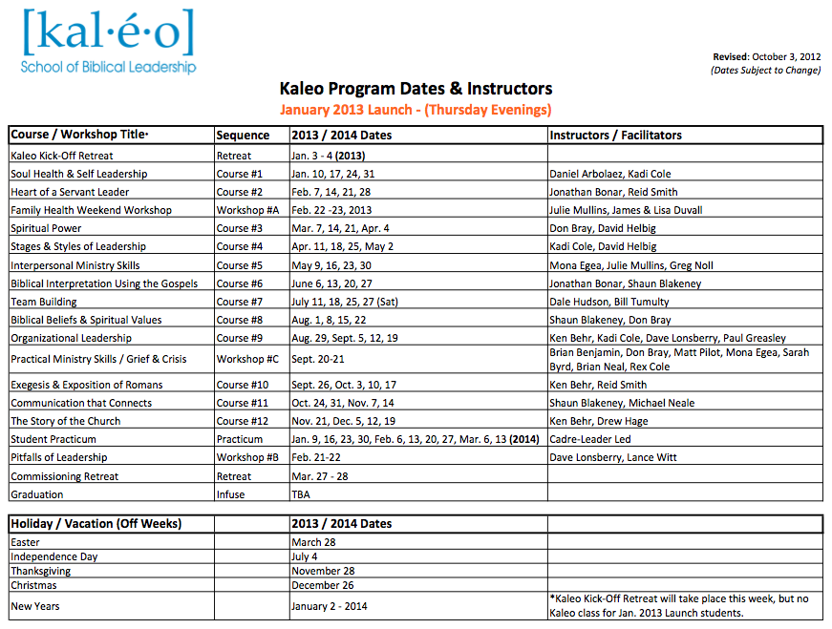

Sample Admissions Process:

Macintosh HD:Users:lize:Dropbox:KALEO TEAM SHARED FILES:APPLICATION DOCS:Kaleo Admissions Process.pdf

**For Additional Resources & Information:**

Visit: <http://www.gochristfellowship.com/kaleo>

**Contact Us:**

Kadi Cole, Executive Director

(561) 799-7600

[kadic@cftoday.org](mailto:kadic@cftoday.org)

Liz Estes, Kaleo Manager

(561) 799-7600, Ext. 3271

[LizE@CFtoday.org](mailto:LizE@CFtoday.org)